[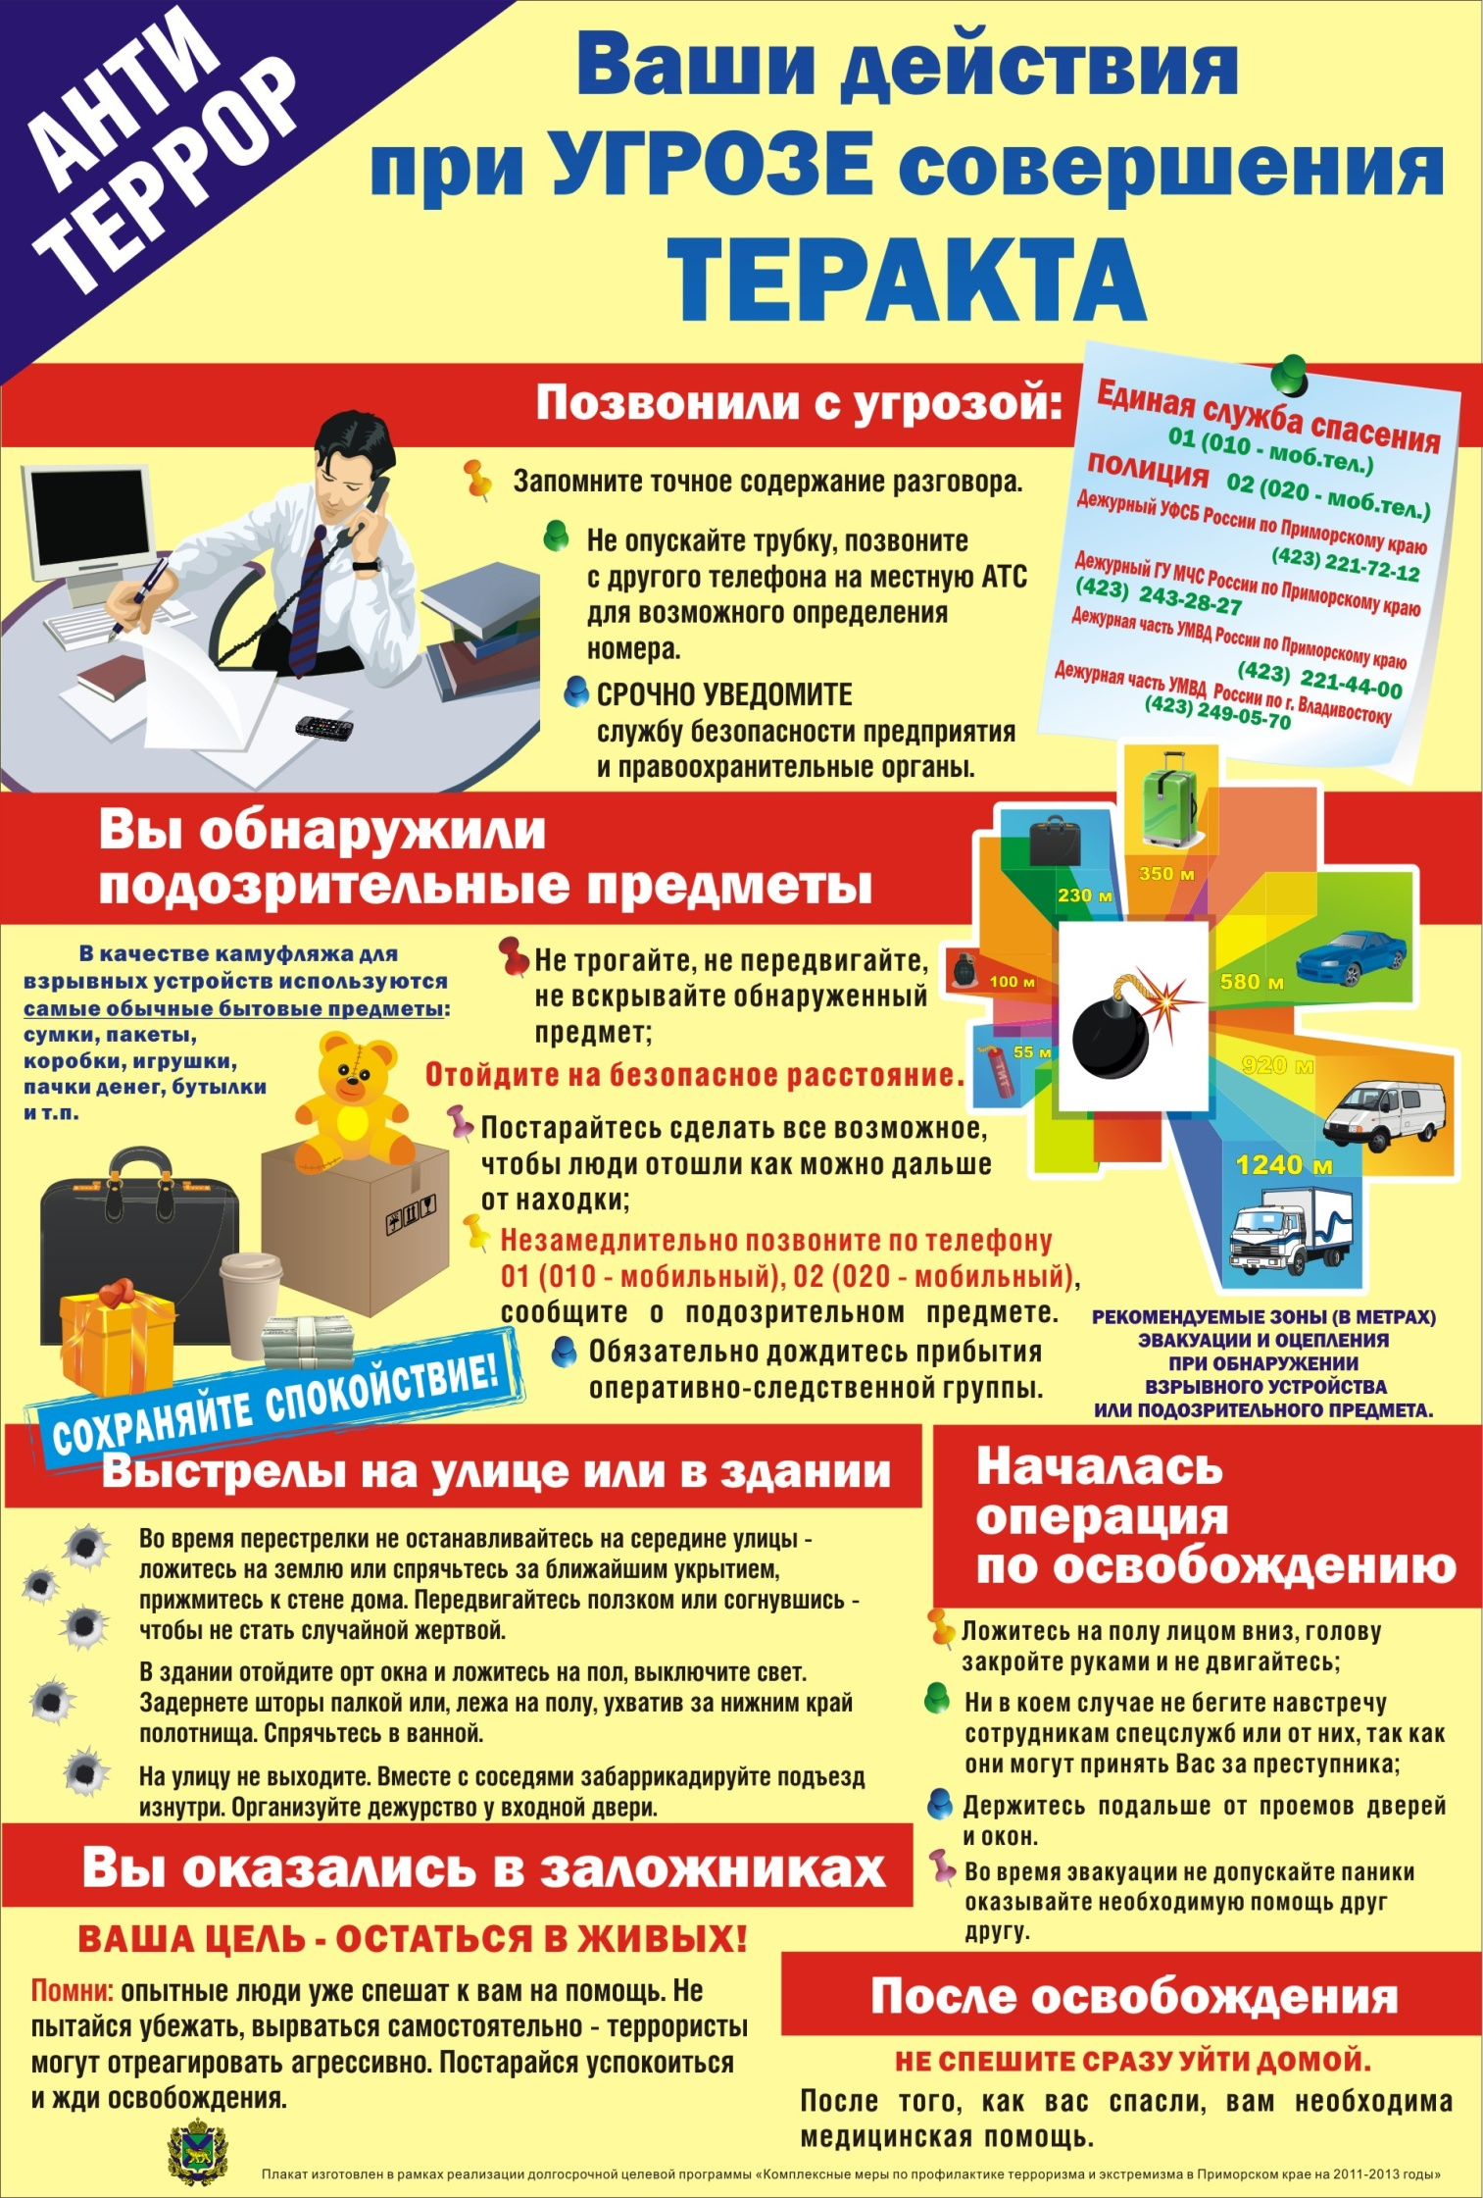](http://www.ds14.partizansk.org/sites/default/files/plakat_vashi_dejstviya_pri_ugroze_.jpg#overlay-context=roditelyam/244_antiterror)

[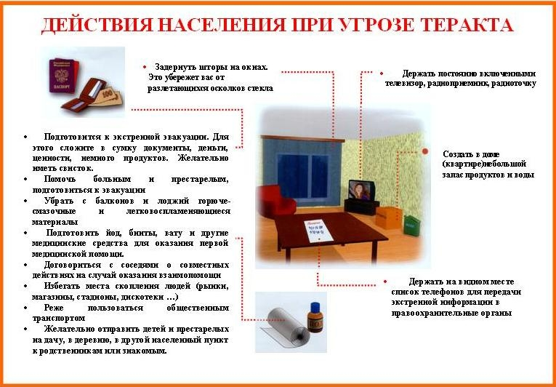](http://www.ds14.partizansk.org/sites/default/files/09220023.jpg#overlay-context=roditelyam/244_antiterror)

[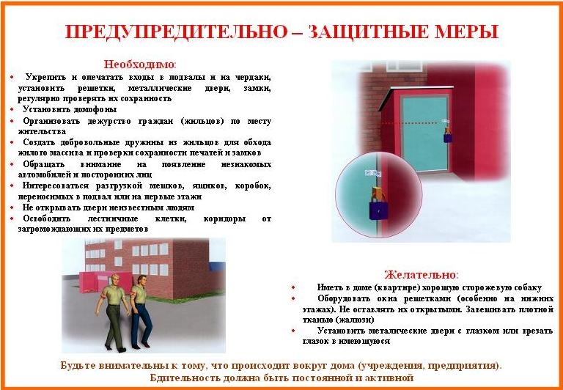](http://www.ds14.partizansk.org/sites/default/files/17786136.jpg#overlay-context=roditelyam/244_antiterror)

[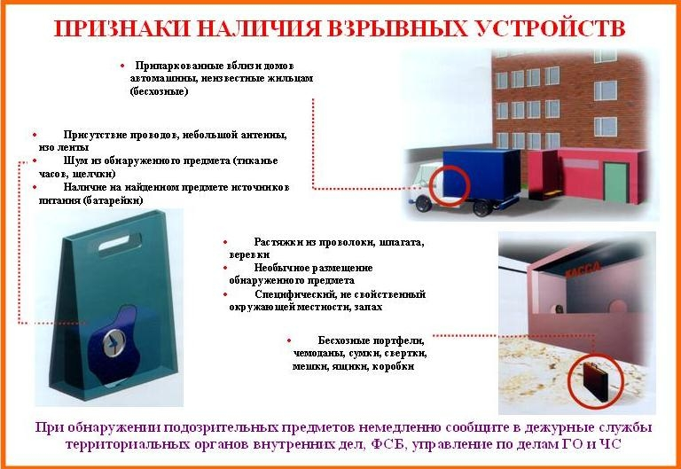](http://www.ds14.partizansk.org/sites/default/files/24957258.jpg#overlay-context=roditelyam/244_antiterror)

[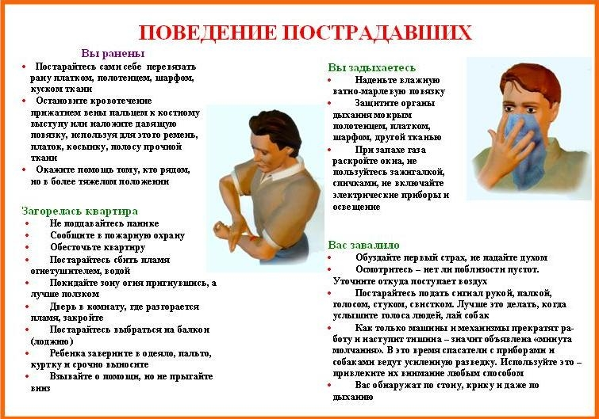](http://www.ds14.partizansk.org/sites/default/files/93608853.jpg#overlay-context=roditelyam/244_antiterror)

[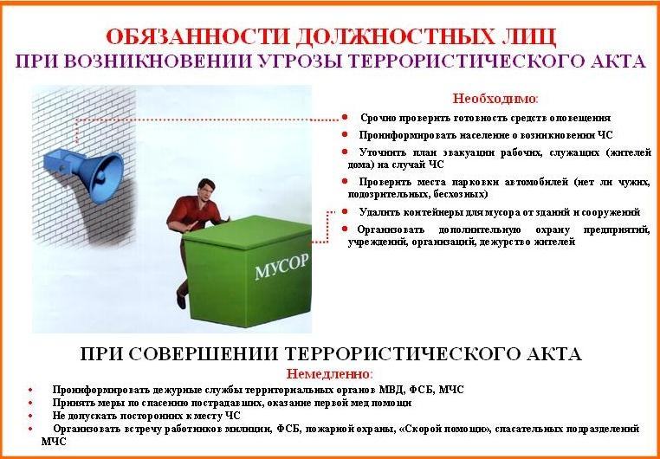](http://www.ds14.partizansk.org/sites/default/files/anti2.jpg#overlay-context=roditelyam/244_antiterror)